**Hammer Legend**

**Rules**

* You are the hammer legend
* Swing your hammer at the floating platforms to propel yourself forward
* If you fall, you lose!

**Requirements**

* Hammer legend and hammer sprites
* Floating (diamond/triangular?) platforms
* Starting launch arc for hammer legend
* Swing animation
* Control hammer legend orientation with finger swipe, release to swing hammer
* Propel hammer legend forward based on angle of contact between hammer and platform
  + Enough momentum to reach next platform with non-perfect contact
  + Zoom past or through some platforms with perfect contact
  + Some animation and sound effect stuff to make this feel good
* Score increases with distance travelled
* Platforms spawned from selection of templates
* More challenging templates spawn as hammer legend travels greater distance

**Not doing yet**

* Background music
* Fancy colourful backgrounds
* Ads
* Earn currency for unlockables (e.g. more backgrounds, hammer and legend skins)
* Shop
  + Pay to remove ads
  + Possibly buy currency
  + Other hammers with different properties (e.g. weight)
* Story, lore

**TODO**

* Platforms should stop player if body hits the platform
* Attach camera to player controller rather than core game
* Use a UI overlay rather than game space canvas so that game space is not finite
* Duplicate diamonds to create jagged floor to navigate and show speed
* Something like a jet pack
* Calculation of perfect contact for speed boost

Should be using force-based movement, not velocity!

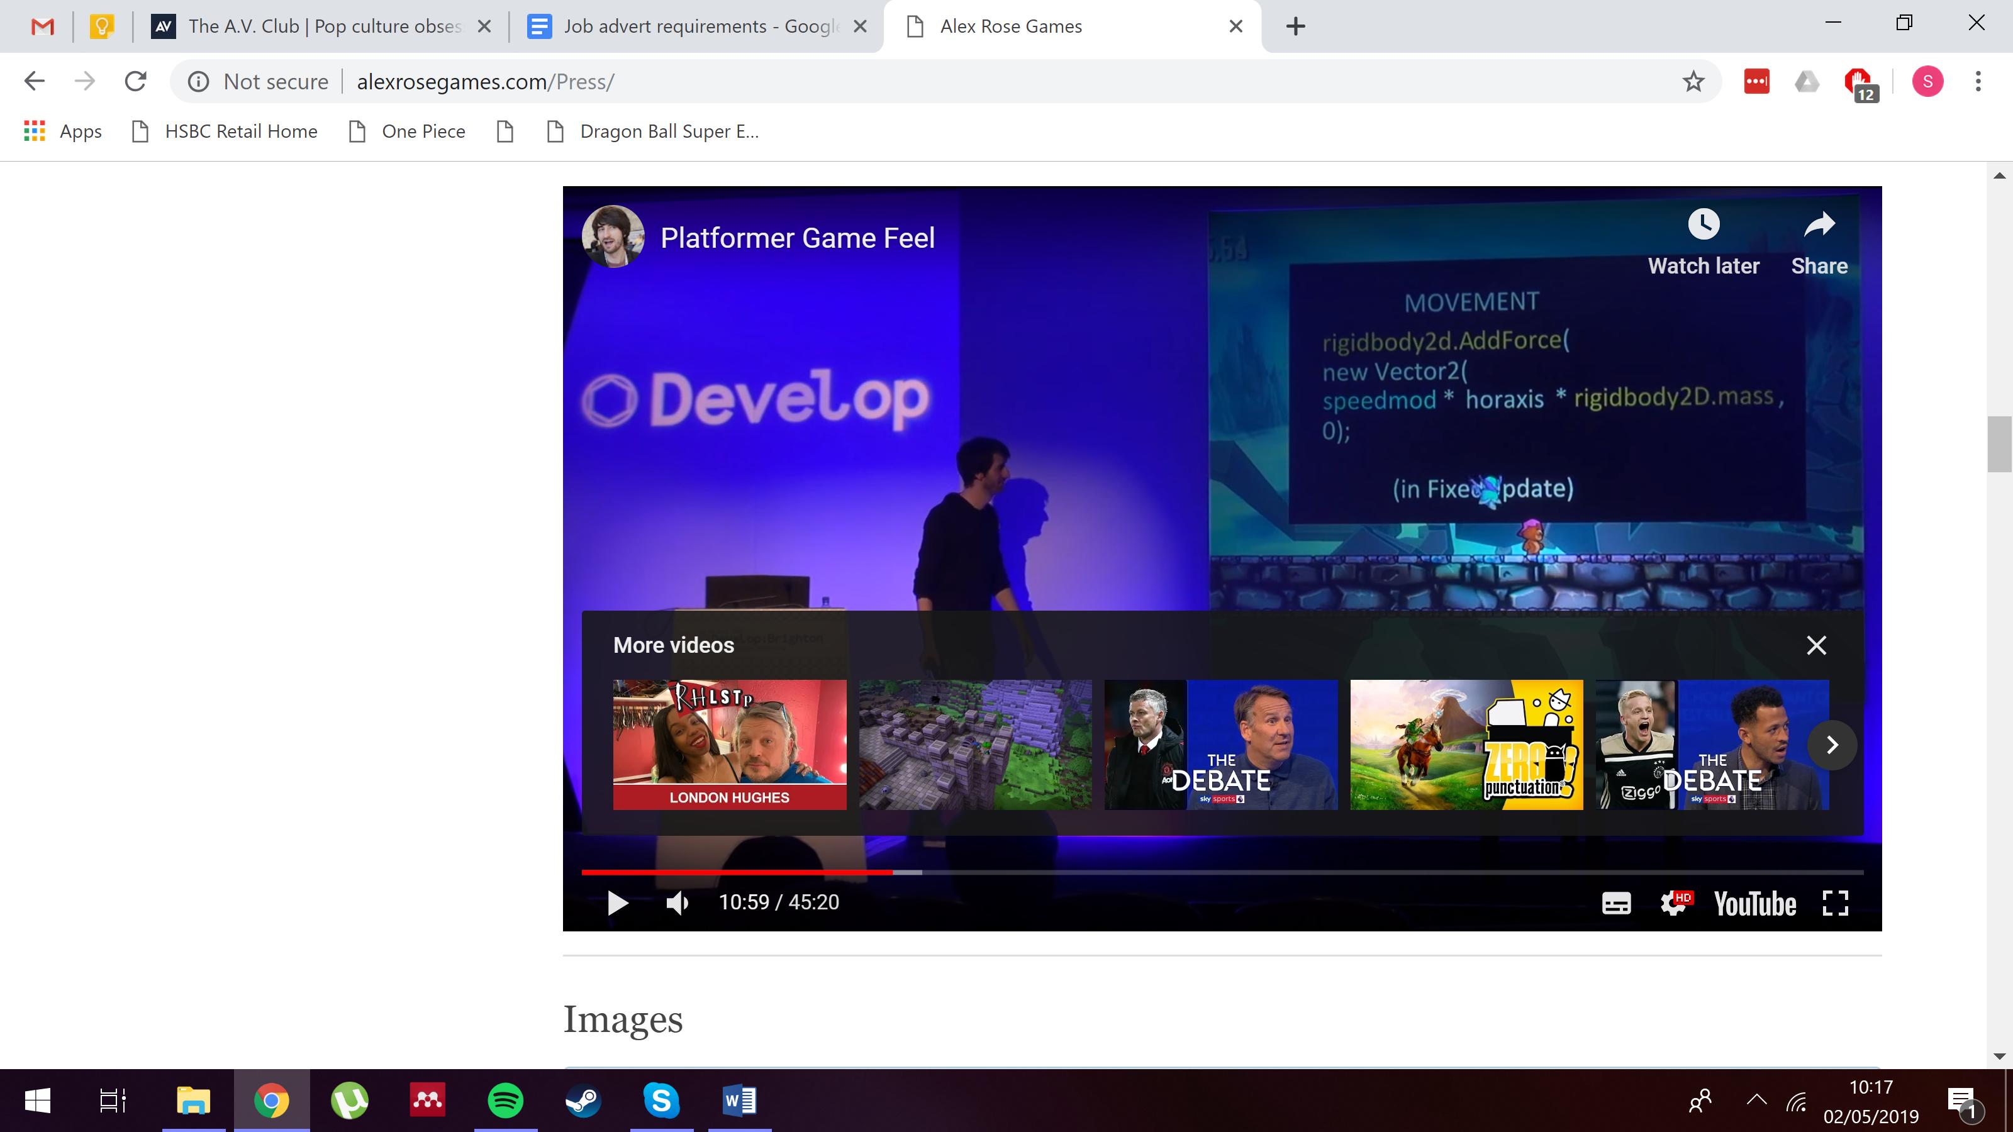

Use FixedUpdate rather than Update so that it’s not framerate dependent and pausing stops everything (assuming pausing sets time scale to 0)!

Use rigidbody2d.drag to stop constant acceleration – using high drag means you need to increase gravity scale too

Use cos wave to add max force at the start of launch and gradually less until no more (on top of base jump strength)

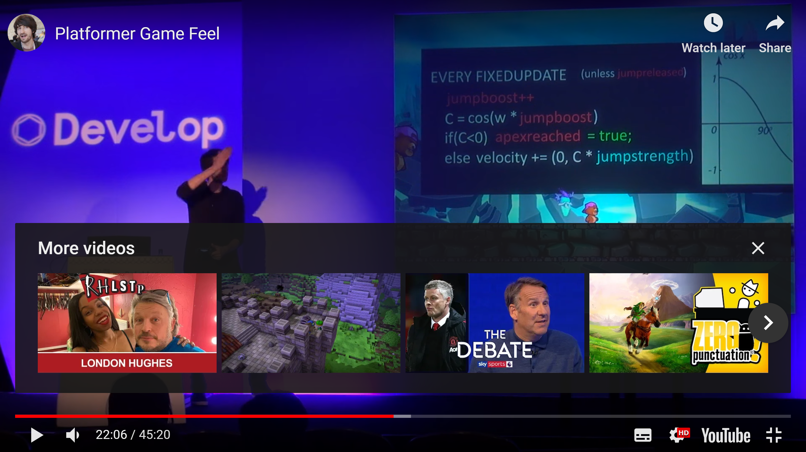

[w determines who quickly you travel along wave]

Formula to make an object move from current position to a destination position smoothly

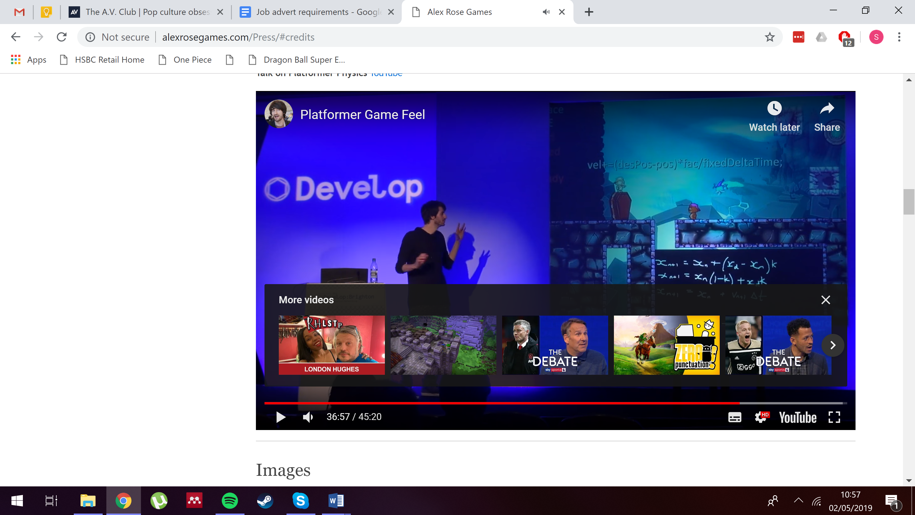

[fac] is a constant between 0 and 1 (1 = instant transmission, 0.1 10% progression each frame)

JUICE IT OR LOSE IT – talk on using visuals to make a game feel better